Assignment - 3

You have been asked to:

● Create Ansible Role called “ansible-new”

● Install apache2 on slave1 and nginx on slave2

Above should be implemented using Ansible Roles

* Specified the roles for Slave1

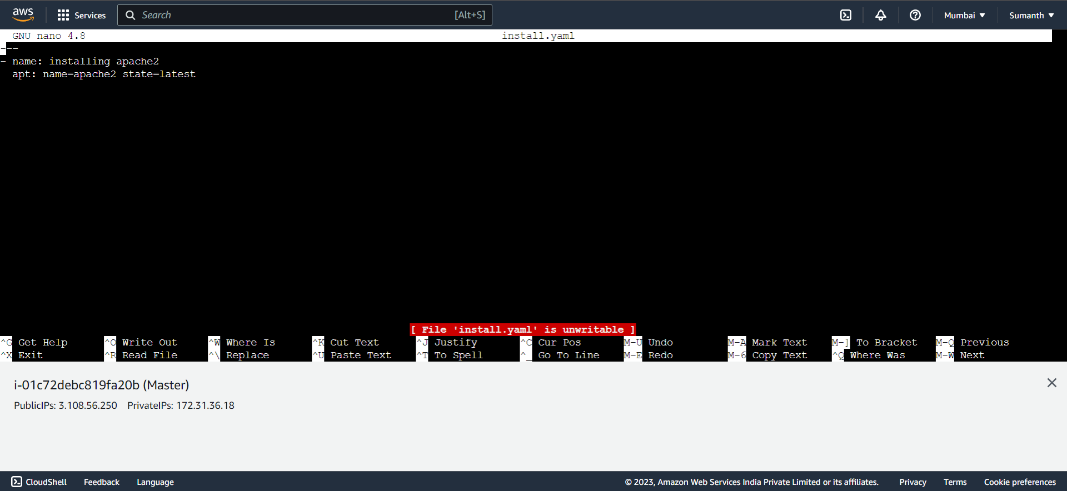

* Included this file in main.yml

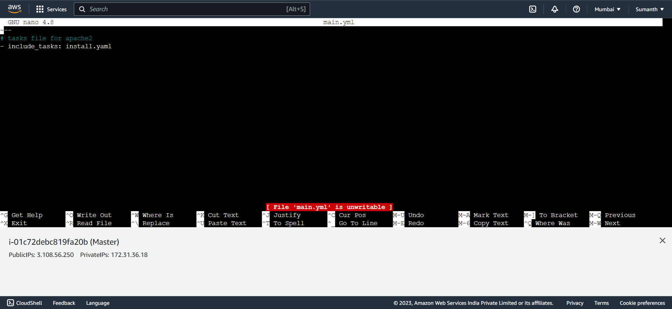

* Specified the roles for Slave2

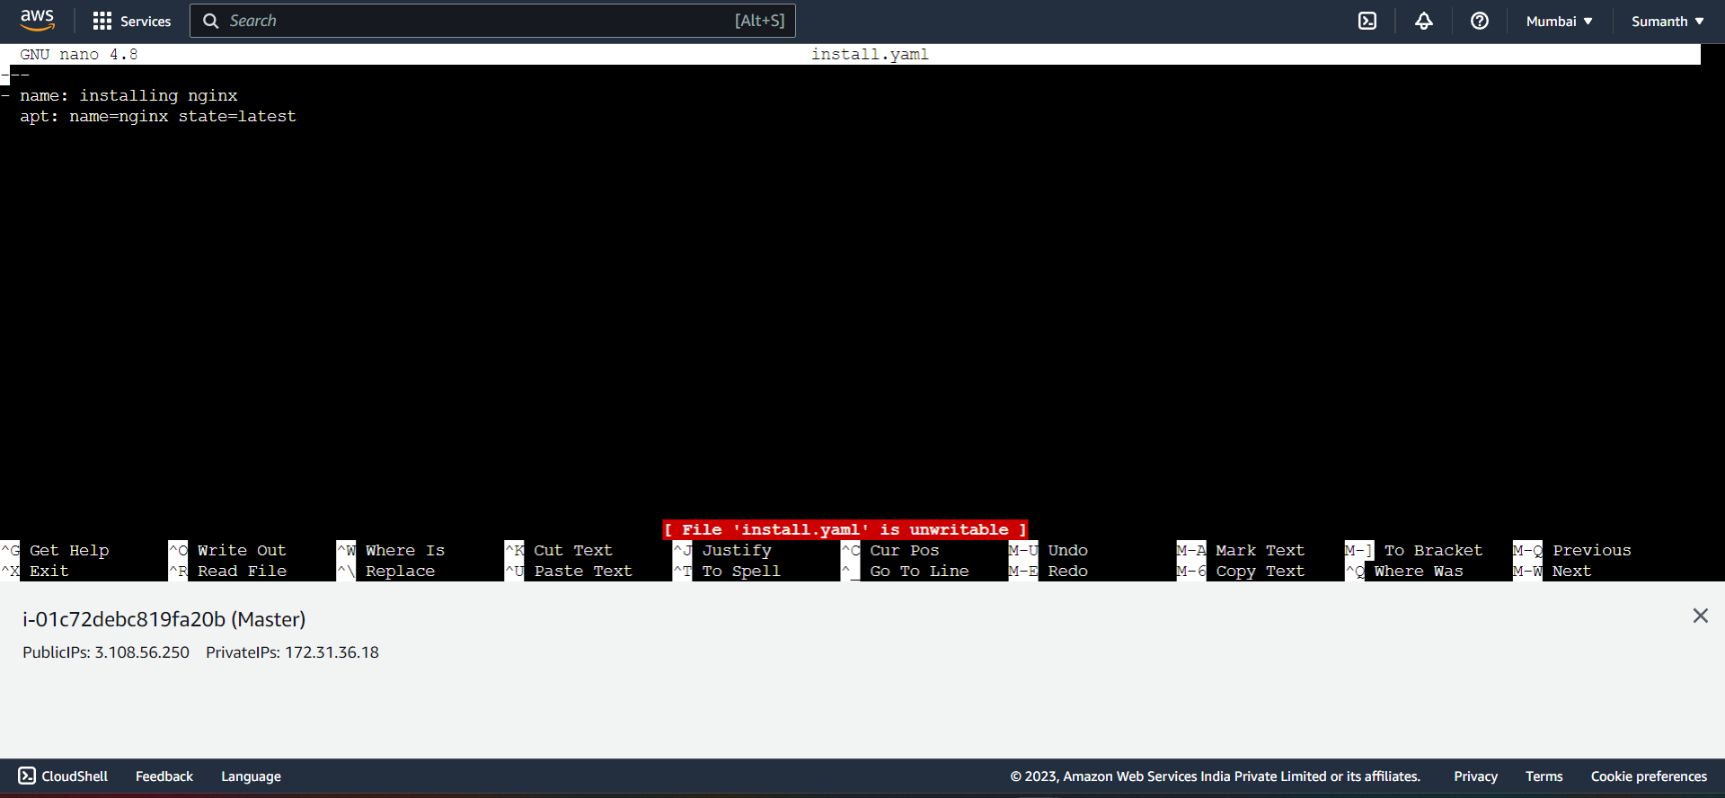

* Included this file in main.yml

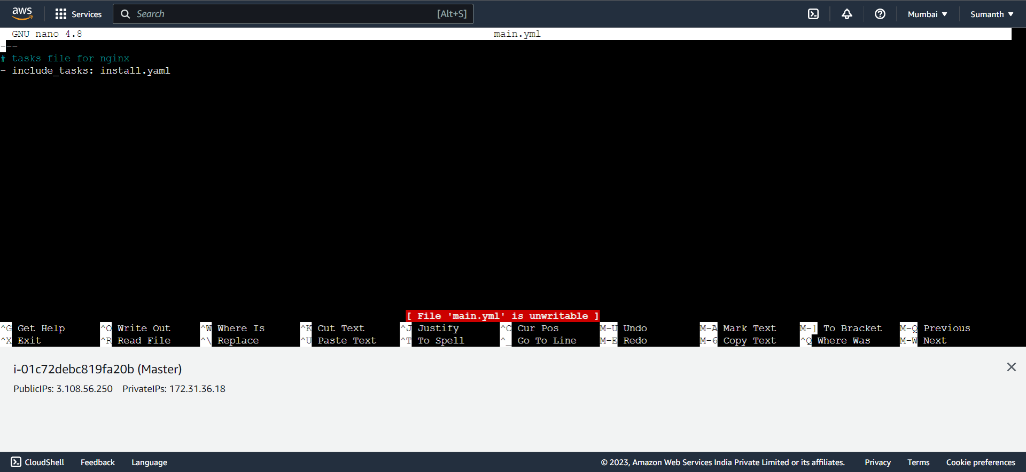

* Specified the playbook for the above tasks

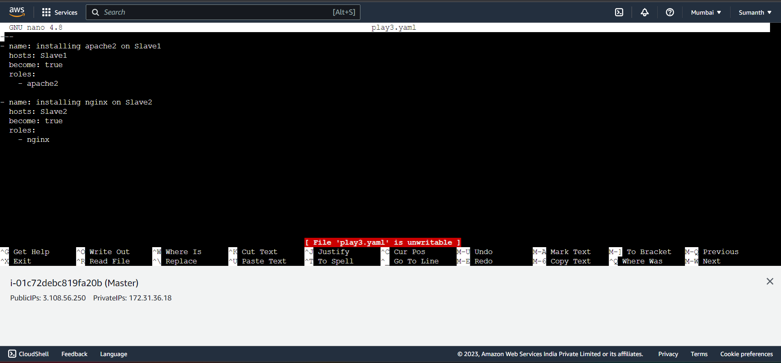

* As per the assignment, installed apache2 on Slave1 and Nginx on Slave2

